INDEX

SR.No. | Content
1 | Introduction to System
2 | System Analysis  Existing System  Need of Computerization  Proposed System  Scope and Objective of Proposed System  Fact Finding Techniques  Feasibility Study
3 | Requirement Specification
4 | System Design  Entity Relationship Diagram  Data Flow Diagram  Class Diagram  Use case Diagram  Activity Diagram  Sequence Diagram  Deployment diagram  Data Dictionary
5 | System Implementation
6 | Input-Output Screen & Reports
7 | Limitations
8 | Future Enhancements
9 | Conclusion
10 | References

- INTRODUCTION

In today's fast-paced business environment, effective inventory management is critical to operational success. Organizations across various industries face challenges in maintaining accurate stock levels, minimizing waste, and optimizing supply chain efficiency. To address these challenges, we present the Smart Inventory Management System, a sophisticated and intelligent solution designed to automate inventory tracking, provide real-time updates, and enhance overall inventory control.
The Smart Inventory Management System is a Python-based application that leverages SQLite for database management, Tkinter for an intuitive graphical user interface, and Pandas for advanced data processing. The system is meticulously designed to eliminate manual errors, enhance efficiency, and provide businesses with an easy-to-use platform for managing stock levels effectively. It ensures real-time tracking of inventory, providing businesses with the ability to monitor stock movements seamlessly. By offering automated low stock alerts and restocking recommendations, the system minimizes the risk of stockouts and overstocking, allowing businesses to optimize inventory levels and prevent unnecessary financial losses.
Security is another integral component of the system, achieved through role-based access control, ensuring that only authorized personnel can manage inventory data. Additionally, the system provides comprehensive reporting and data visualization tools, allowing businesses to generate detailed insights into their stock trends, sales performance, and overall inventory health.
Designed to cater to businesses of all sizes, from small-scale retailers to large enterprises and warehouse management systems, this solution is highly scalable, adaptable, and user-friendly. The primary objective of this system is to streamline inventory processes, reduce inefficiencies, and allow businesses to focus on their core operations while maintaining a seamless inventory workflow. By integrating automation and structured data management, the system serves as a valuable tool in modern inventory management, ensuring accuracy, efficiency, and long-term business sustainability.

SYSTEM ANALYSIS

EXISTING SYSTEM

Traditional inventory management systems are often plagued by inefficiencies due to their reliance on manual data entry, spreadsheets, or outdated software. Here are the key challenges faced by businesses using existing inventory management methods:
- Human Errors in Data Entry: Manual inventory management involves entering stock levels, sales, and restocking data into spreadsheets or paper records, increasing the likelihood of errors. Incorrect entries can lead to stock discrepancies and financial losses.
- Inefficient Tracking and Reporting: Without an automated system, businesses struggle to track real-time stock levels. Delayed updates mean businesses may run out of essential products without notice, disrupting sales and operations.
- Overstocking or Understocking Issues: Businesses often overstock products due to a lack of predictive analytics, leading to wasted storage space and tied-up capital. Conversely, understocking results in lost sales and dissatisfied customers.
- Lack of Real-time Monitoring: Most traditional inventory systems do not offer real-time updates, making it difficult to monitor stock movements accurately. This results in delayed restocking, causing interruptions in supply chains.
- Limited Role-based Access: Many businesses rely on systems where all employees have the same access level, increasing the risk of unauthorized changes or data tampering.
These challenges highlight the need for a modern, automated, and predictive inventory management system, which the Smart Inventory Management System aims to provide

NEED OF COMPUTERIZATION

To overcome the challenges of traditional inventory management, the Smart Inventory Management System introduces a centralized and automated approach to inventory tracking. It eliminates the need for businesses to rely on manual stock recording by providing a structured digital platform that allows for efficient stock monitoring and management. By leveraging real-time data, businesses can keep track of inventory movements, reducing the risk of mismanagement and ensuring optimal stock levels.
This system simplifies the inventory process by offering an intuitive and user-friendly interface, allowing employees to effortlessly add, update, and track stock information. Automated alerts and notifications ensure that businesses never run out of essential products, while real-time updates eliminate delays in restocking. By replacing outdated inventory management techniques with a smart, digital solution, businesses can operate with greater accuracy and efficiency.
With the Smart Inventory Management System, businesses can say goodbye to inefficient manual tracking methods. This system provides a cost-effective, time-saving, and highly reliable solution that enhances the entire inventory management process, from stock tracking to order fulfilment and beyond.

PROPOSED SYSTEM

The Smart Inventory Management System introduces several key features to improve efficiency and accuracy in inventory control.
- Automated Stock Monitoring: The system automatically updates stock levels whenever sales occur or new stock is added. This ensures that inventory records remain up to date without requiring manual intervention, reducing human errors and enhancing efficiency.
- Low Stock Alerts & Restocking Recommendations: When stock levels reach a critical threshold, the system generates real-time alerts to notify users. It also provides restocking recommendations based on predefined thresholds, ensuring that businesses can replenish stock in a timely manner and prevent shortages.
- User and Role Management: The system allows administrators to define specific roles and access levels for different users, such as managers and staff. This ensures secure inventory management by restricting unauthorized access and maintaining accountability.
- Efficient Database Management (SQLite): By leveraging SQLite, the system provides a lightweight yet powerful database management solution. It ensures fast and structured data handling, enabling seamless inventory operations while maintaining data integrity.
By implementing these advanced features, businesses can streamline inventory management, reduce operational inefficiencies, and improve overall productivity.

SCOPE AND OBJECTIVE OF PROPOSED SYSTEM

Scope of the Proposed System:

The Smart Inventory Management System facilitates:
- Stock tracking and automated updates.
- Order management and inventory adjustments.
- Multi-user access with role-based permissions.
- Data visualization, analytics, and reporting.

Objectives of the Proposed System:

- Enhance accuracy in inventory tracking: The system ensures that stock levels are accurately recorded and updated in real-time, reducing discrepancies and preventing mismanagement.
- Minimize stock discrepancies by automating updates: Automated stock adjustments eliminate human errors, ensuring that inventory records remain consistent and reliable at all times.
- Improve operational efficiency: The system optimizes inventory workflows, reducing manual effort and allowing businesses to focus on strategic decision-making.
- Provide actionable insights through data-driven reports: Real-time reporting and analytics help businesses track inventory trends, monitor stock levels, and make informed purchasing decisions.
- Ensure ease of use with a simple and intuitive graphical user interface (GUI): A user-friendly interface allows employees to manage inventory effortlessly, minimizing training time and improving user adoption.

FACT FINDING TECHNIQUES

Fact-finding techniques are essential methods used in the early stages of system analysis and design to gather information and understand system requirements. These techniques involve interacting with stakeholders, studying existing documents, observing processes, and conducting interviews or surveys. The following are the key techniques used in developing the Smart Inventory Management System:
- Interviews: Direct conversations with inventory managers, business owners, and system users helped gather insights into existing challenges and requirements. Structured and unstructured interviews provided a clear understanding of user expectations and system functionality.
- Surveys and Questionnaires: Distributed among employees and stakeholders, surveys helped collect standardized responses regarding inventory management challenges and feature preferences. The data gathered was analyzed to identify trends and requirements.
- Record Review: Existing business records, inventory logs, and transaction histories were examined to understand stock movement patterns, past errors, and inefficiencies in the traditional system. Reviewing previous reports provided valuable data for designing an improved system.
- Observation: Real-time observation of inventory processes allowed for the identification of bottlenecks, inefficiencies, and improvement areas. By studying how inventory was handled manually, crucial insights were gathered to ensure the new system effectively addressed existing limitations.
By employing these fact-finding techniques, the Smart Inventory Management System was designed to provide an efficient, automated, and reliable solution for modern inventory management needs.

FEASIBILITY STUDY

Economic Feasibility
The Smart Inventory Management System is a cost-effective solution that automates inventory tracking, reducing operational costs and minimizing stock mismanagement. It eliminates excessive manual labor, ensuring accurate stock levels while keeping expenses under control. By improving inventory accuracy and reducing waste, businesses can enhance financial planning and increase profitability.
Technical Feasibility
Built using Python, SQLite, Pandas, and Tkinter, the system is lightweight, scalable, and easy to integrate with existing infrastructure. It requires minimal maintenance and runs efficiently without high-end hardware, making it suitable for businesses of all sizes. Supporting both local and cloud-based operations, it ensures data security and remote accessibility when needed.
Operational Feasibility
Designed for seamless integration, the system requires minimal training due to its user-friendly interface. Automated stock updates, low stock alerts, and role-based access improve usability while reducing errors. With real-time inventory insights and reporting, businesses can make informed decisions, streamline operations, and enhance overall efficiency.
By addressing economic, technical, and operational factors, the Smart Inventory Management System provides a reliable and scalable solution for modern inventory management.

REQUIREMENT SPECIFICATION

Functional Requirements:

- User Authentication & Role Management: Implements a secure login system where users register and log in based on their assigned roles, such as admin, manager, or staff. Administrators have the ability to define permissions and control access levels, ensuring data security and user accountability.
- Stock Monitoring & Alerts: The system automatically updates stock levels when items are added or sold. It generates real-time notifications when stock levels fall below a predefined threshold, preventing stockouts and ensuring timely restocking.
- Inventory Data Entry & Modification: Users can input new inventory items, update pricing, descriptions, and stock levels, and remove obsolete products. The system maintains an audit log of all modifications to ensure transparency and accountability.
- Order Management: Tracks all incoming and outgoing stock transactions, linking them to suppliers and customers. It maintains purchase and sales order records, providing a detailed overview of pending and completed orders.
- Report Generation & Exporting: The system generates various reports, including sales summaries, inventory status, and stock movement trends. Reports can be exported in multiple formats such as PDF, Excel, or CSV for further analysis and record-keeping.
Performance Requirements
- Fast data processing to ensure real-time stock updates and minimize delays in transactions.
- Optimized database queries for efficient data retrieval, reducing system response time.
- User-friendly graphical interface designed for ease of use, ensuring a seamless user experience.

SYSTEM DESIGN

Entity Relationship Diagram

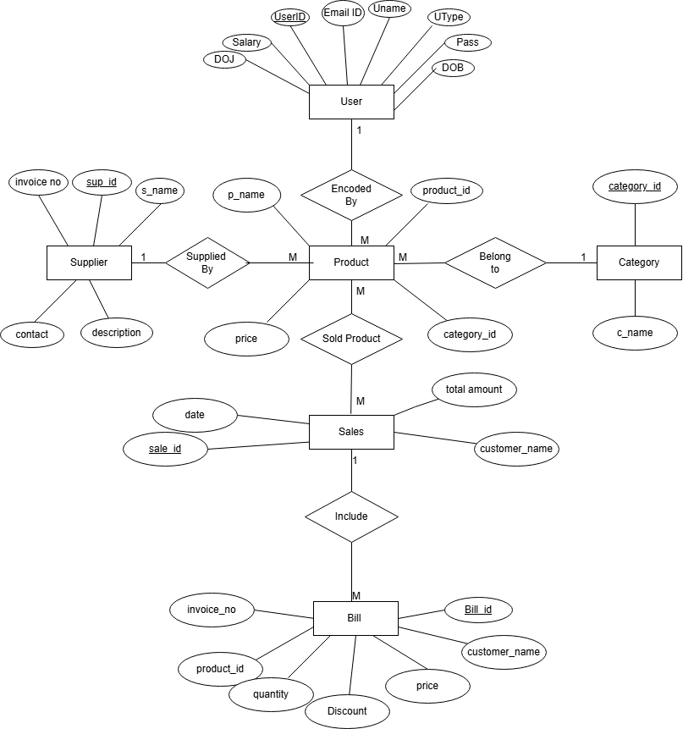
Dataflow Diagram

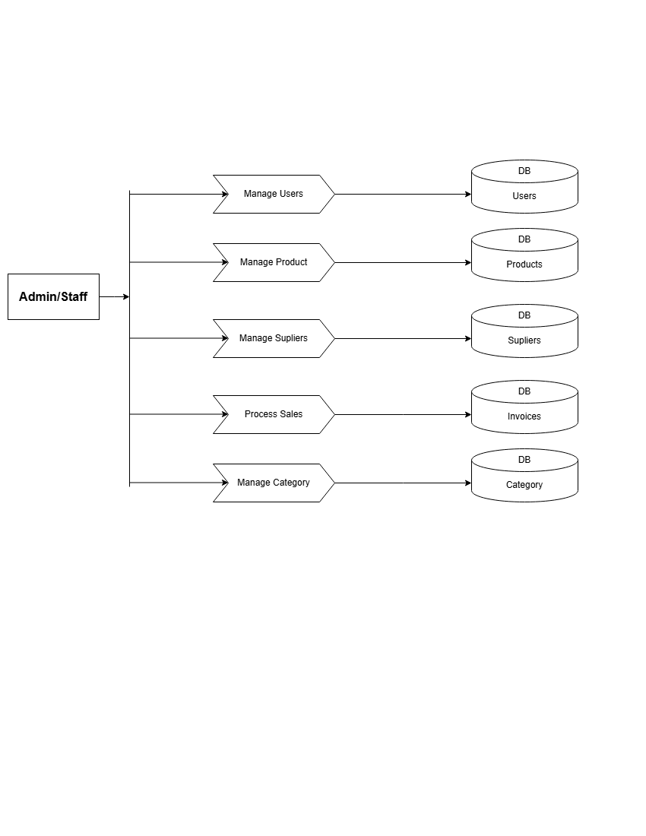
Class Diagram

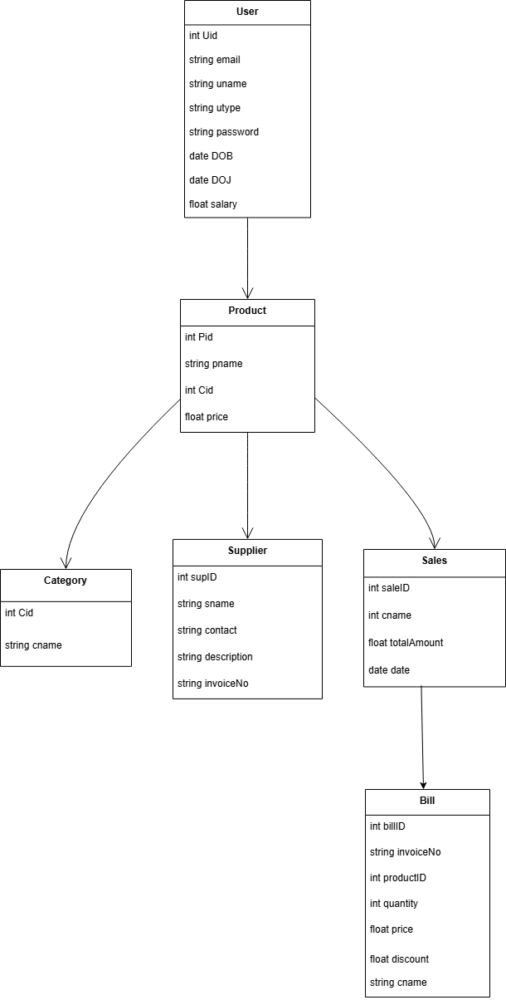
Use Case Diagram

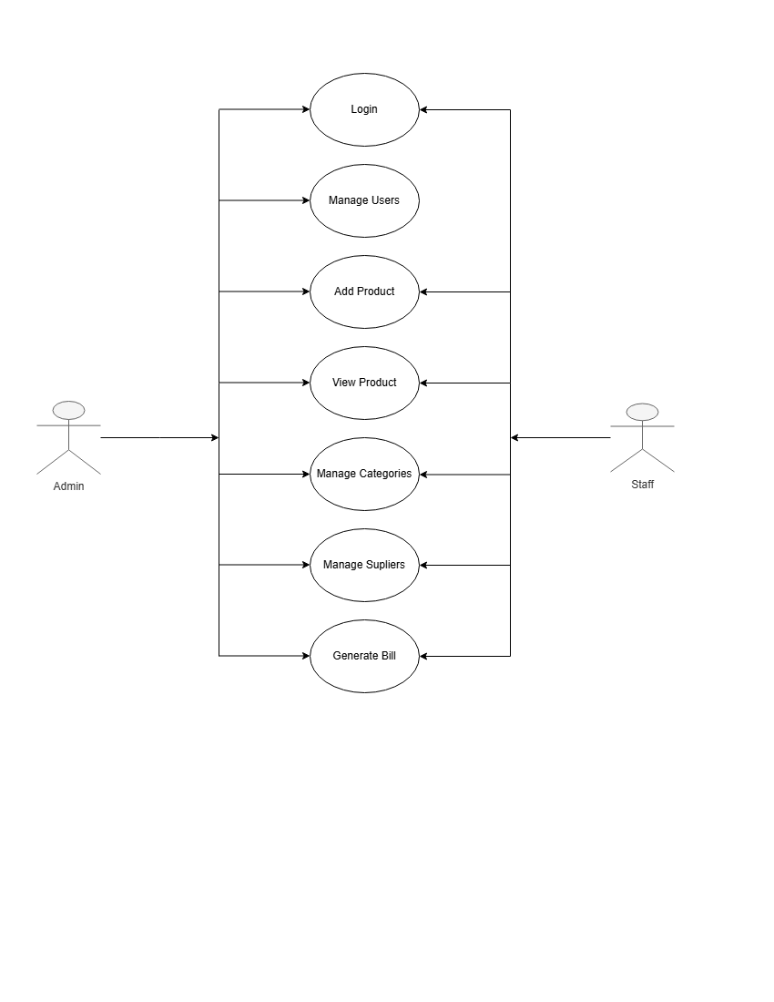

Activity Diagram

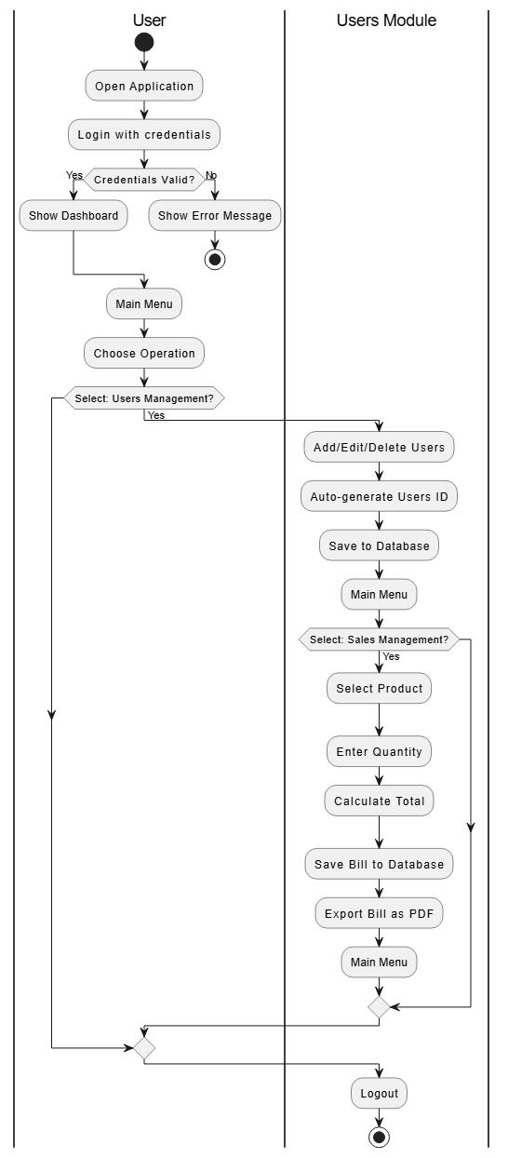

Admin Side:
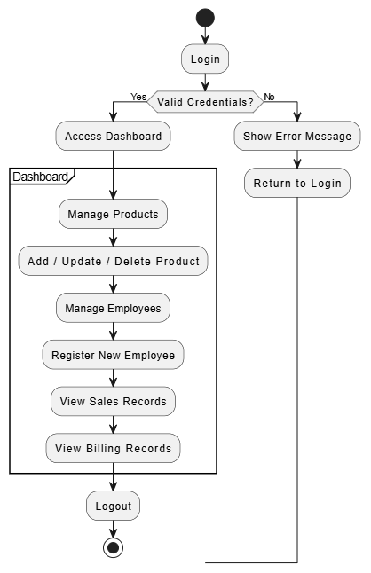

Sequence Diagram

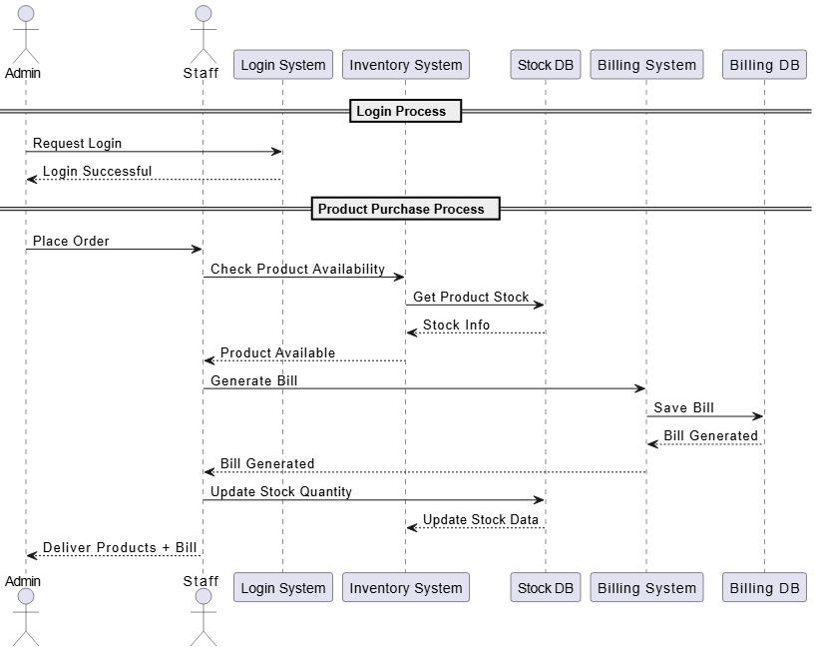
Deployment diagram

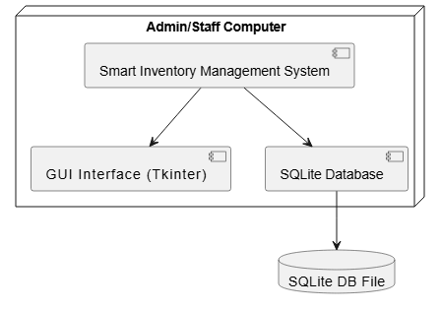

Data Dictionary

Users
Name | Type | Schema
Uid | INT | “Uid” INTEGER(PK)
Uname | TEXT | “Uname” TEXT
Email | TEXT | “Email” TEXT
Gender | TEXT | “Gender” TEXT
Contact | INT | “Contact” INTEGER
DOJ | TEXT | “DOJ” TEXT
DOB | TEXT | “DOB” TEXT
Pasword | TEXT | “Password” TEXT
Utype | TEXT | “UType” TEXT
Address | TEXT | “Address” TEXT
Salary | FLOAT | “Salary” FLOAT

Product
Name | Type | Schema
Pid | INT | “Pid” INTEGER(PK)
Pname | TEXT | “Pname” TEXT(pk)
Price | INT | “Price” INT
Qty | INT | “Qty” INT
Status | TEXT | “Status” TEXT
Cname | TEXT | “Cname” TEXT(FK)
Sid | INT | “Sid”INT(FK)

Category

Name | Type | Schema
Cid | INT | “Cid” INT
Cname | TEXT | “Cname” TEXT(PK)

Supplier

Name | Type | Schema
Sid | INT | “Sid” INT (PK)
Sname | TEXT | “Sname” TEXT
Invoice | INT | “Invoice” INT
Contact | INT | “Contact”INT
Description | TEXT | “Description” TEXT

Sales
Name | Type | Schema
Salesid | INT | “Salesid”INT(pk)
Cname | TEXT | “Cname”TEXT(PK)
Totalamount | FLOAT | “Totalamount”FLOAT
Date | INT | “Date”INT

Bill

Name | Type | Schema
bilid | INT | “billid”INT(PK)
invoice no | INT | “invoiceno” INT
pname | TEXT | “pname” TEXT(FK)
cname | TEXT | “cname” TEXT(FK)
quantity | INT | “quantity” INT
price | INT | “price” INT
discount | INT | “discount” INT

SYSTEM IMLEMENTATION

System implementation is the process of translating the design and requirements of a system into a fully functional software application. The Smart Inventory Management System was developed using Python and Tkinter for the GUI and SQLite as the database. The system was implemented in a modular structure to ensure easy development, testing, and maintenance.
- Requirement Gathering
All functional requirements such as product management, billing, stock updates, employee management, and secure login were clearly defined during the planning phase.
- Technology Stack Used
- Python – Core programming language for backend logic
- Tkinter – GUI design
- SQLite – Database for storing products, sales, billing, and employee data
- Database Implementation
The database was designed with proper structure and relationships. Key tables include:
- products – item details
- sales – sales records
- sale_items – product-wise sale details
- billing – bill and customer information
- employees – staff records with auto-generated employee IDs
- GUI Development
The interface was created using Tkinter with screens for:
- Admin login & staff registration
- Product management
- Customer billing
- Viewing sales and billing records
- Functional Module Implementation
- Product Module – Add/update/delete products and track stock
- Sales & Billing Module – Add sales, calculate totals, deduct stock
- Employee Module – Staff registration with auto-generated IDs
- Authentication Module – Role-based secure login
- Reports Module – View inventory and sales records
- Stock Update Mechanism
Stock quantity is automatically updated after each sale. The system does not include stock alerts or restocking suggestions.
- Testing and Validation
Each module was tested to ensure correct functionality and smooth workflow.
- Deployment
The system runs as a lightweight, standalone desktop application with no complex setup

INPUT-OUTPUT SCREEN & REPORTS

- Dashboard page(admin)
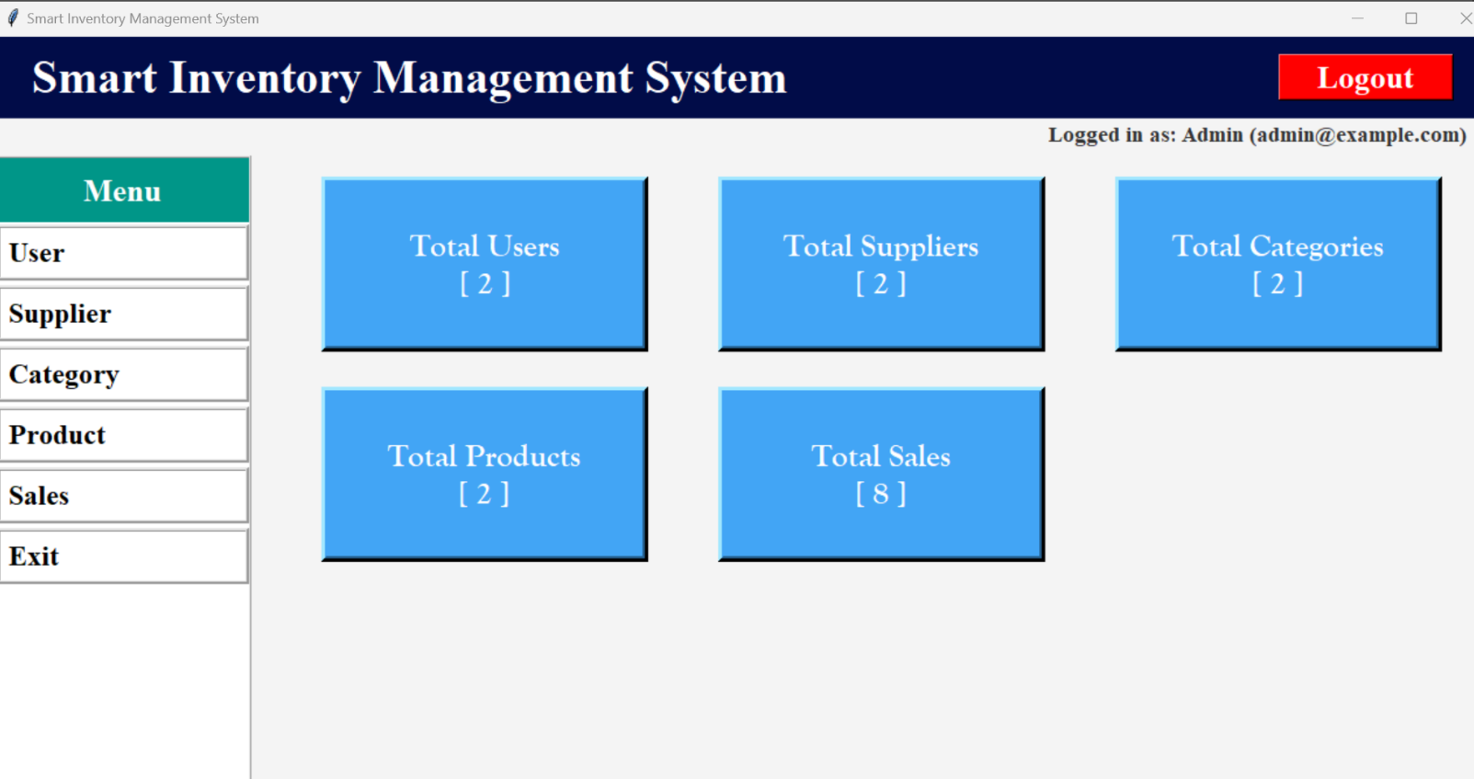

2.Dashboard Page (staff)
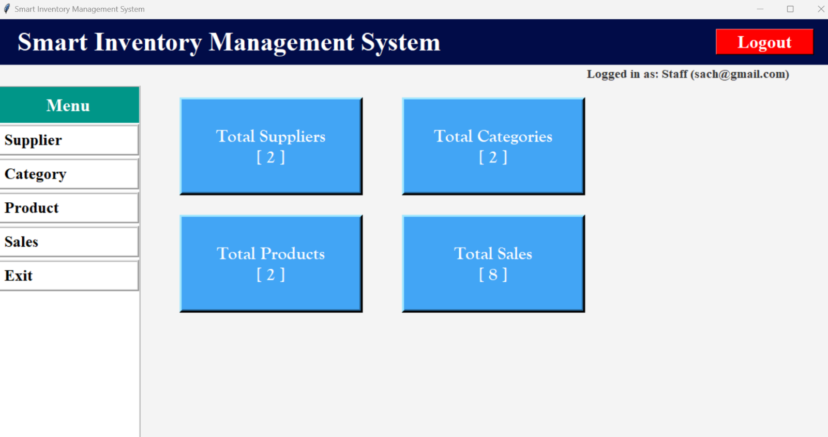
3.Login page
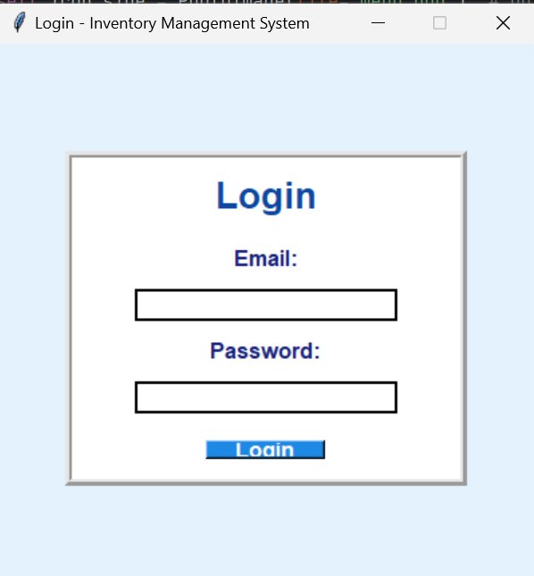
4.User Page
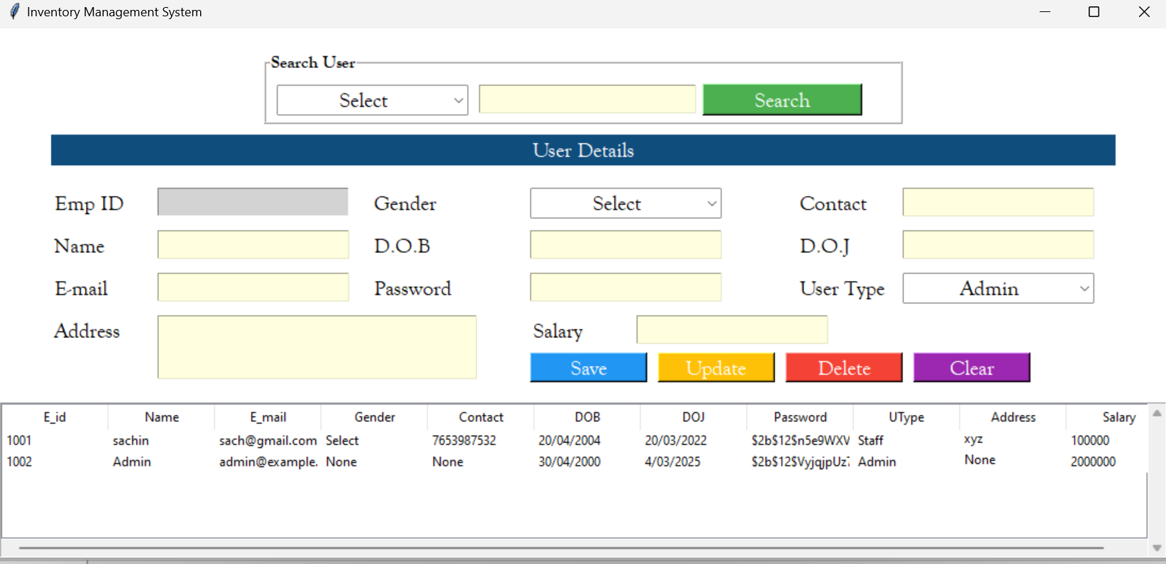

5.Supplier page
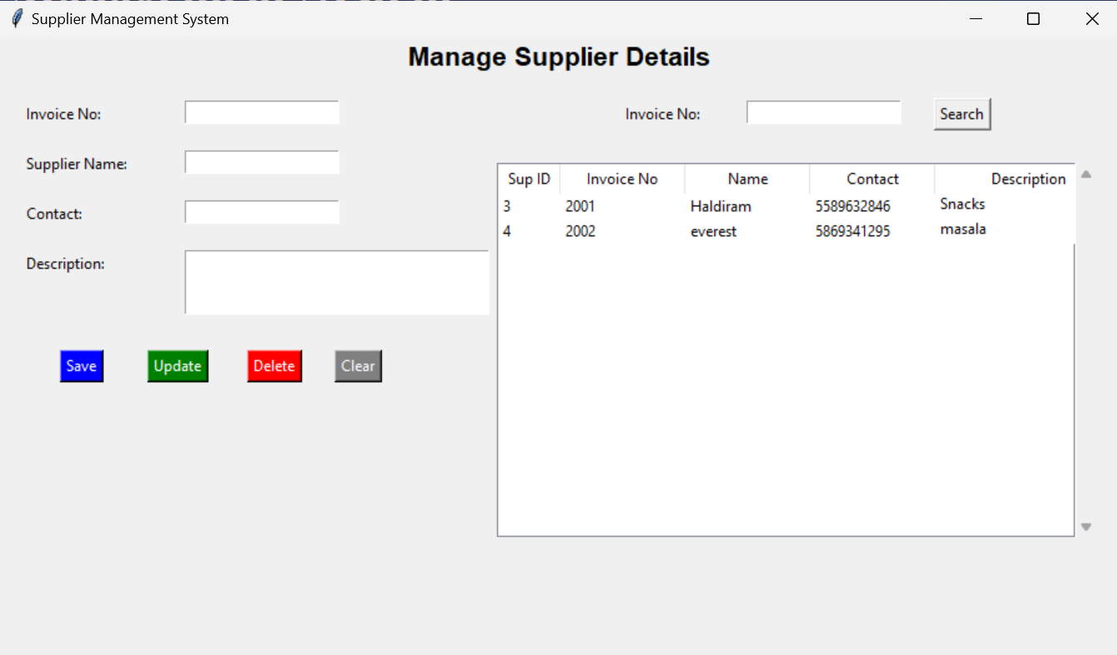

6.Category Page

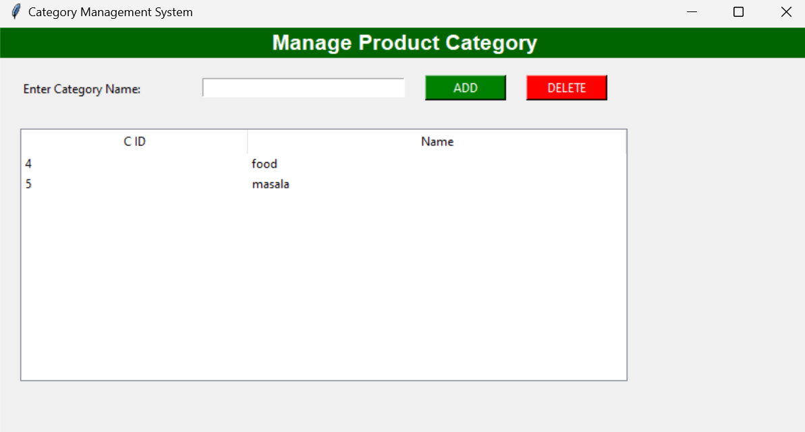
7.Product Page
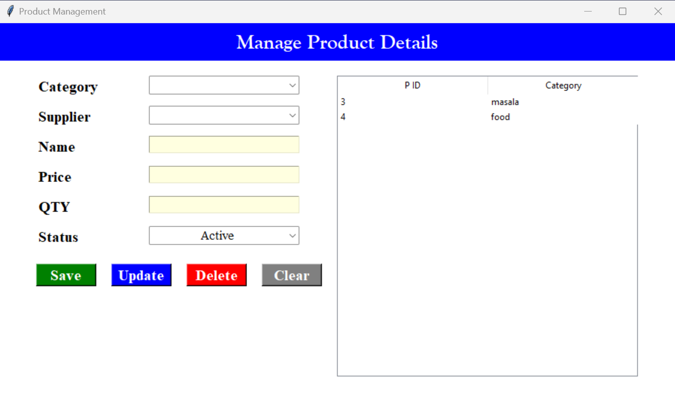
8.Sales Page

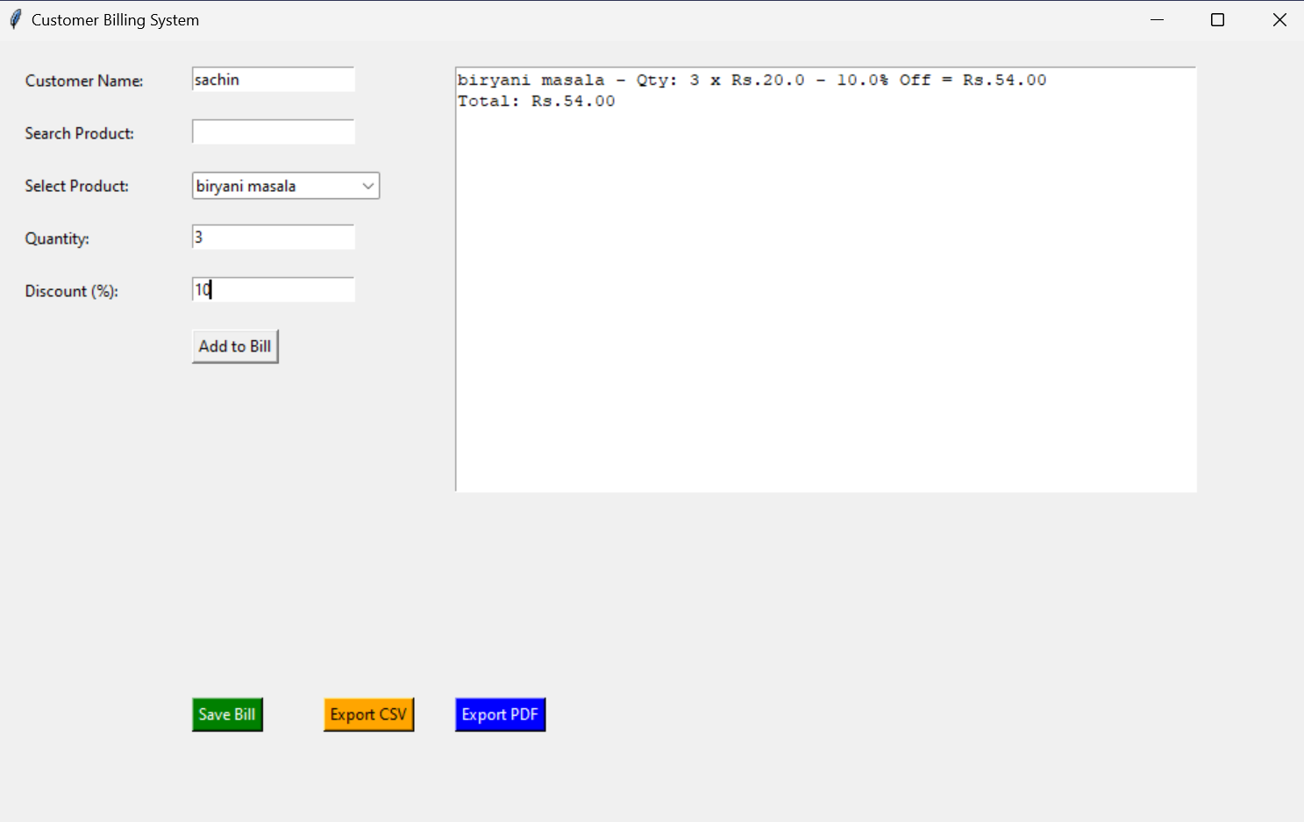

LIMITATIONS

Despite offering a reliable and user-friendly platform for inventory management, the system has some limitations:
- No Stock Alert Notifications: The system does not generate automatic alerts for low stock or restocking suggestions.
- Single Machine Access: The system is desktop-based and does not support multi-user access over a network or cloud environment.
- Limited Reporting Features: While basic inventory and sales records are available, the system does not include advanced reporting or data visualization tools.
- No Barcode Integration: The system currently does not support barcode scanning for product identification or billing.
- No Backup & Recovery Module: The system lacks an automated backup and recovery mechanism in case of data loss or corruption.
- Scalability Constraints: Being built on SQLite, the system is suitable for small to mid-sized setups but may not handle large-scale enterprise needs efficiently.

FUTURE ENHANCEMENTS

Although the current system fulfills basic inventory management needs, the following enhancements can improve functionality and scalability in future versions:
- Stock Alert Notifications: Integration of low stock alert features to notify the admin when inventory reaches a critical level.
- Barcode Scanner Support: Addition of barcode scanning for quick product identification during sales and billing.
- Cloud Integration: Upgrading the system to work on a cloud platform to allow multi-user access from different locations.
- Advanced Reporting Tools: Implementation of graphical dashboards and advanced data analytics for better business insights.
- Automated Backup System: Addition of an auto-backup feature to secure data and prevent loss in case of system failure.
- Mobile Application: Development of a mobile version of the system for convenient on-the-go access and management.
- Multi-user Role Access: Expanding role-based permissions with more control levels like supervisor, cashier, etc.

CONCLUSION

The Smart Inventory Management System provides a simple, efficient, and reliable solution for managing stock, sales, billing, and employee records. It reduces manual workload by automating key processes like stock updates and billing, ensuring accuracy and saving time.
Developed using Python, Tkinter, and SQLite, the system is lightweight, easy to use, and suitable for small to mid-sized businesses. With features like product management, sales tracking, employee registration, and role-based login, it streamlines daily inventory operations effectively.
Though the current version has some limitations, it lays a strong foundation for future improvements such as stock alerts, advanced reports, and mobile accessibility. Overall, the system improves business productivity and brings more control and transparency to inventory management tasks.

REFERENCES

Python Official Documentation –
Used for understanding Python syntax, standard libraries, and best practices for backend development.
(https://docs.python.org)
Tkinter GUI Programming Guide –
Referred for designing graphical user interfaces using Tkinter, including form creation, widgets, and event handling.
(https://docs.python.org/3/library/tkinter.html)
SQLite Official Documentation –
Used for understanding database structure, query execution, and integrating SQLite into a Python-based application.
(https://www.sqlite.org/docs.html)
W3Schools – SQL Tutorial –
Helpful in learning SQL queries and database management concepts such as insert, update, delete, and join operations.
(https://www.w3schools.com/sql)
GeeksforGeeks – Python Programming Resources –
Used for understanding Python programming concepts, code examples, and logical implementation of modules.
(https://www.geeksforgeeks.org/python-programming-language/)
Stack Overflow – Developer Community –
Used to find solutions for errors and implementation challenges faced during development.
(https://stackoverflow.com)
TutorialsPoint – Software Engineering Concepts –
Referred for theoretical understanding of system development life cycle, system design, and feasibility studies.
(https://www.tutorialspoint.com/software_engineering)

